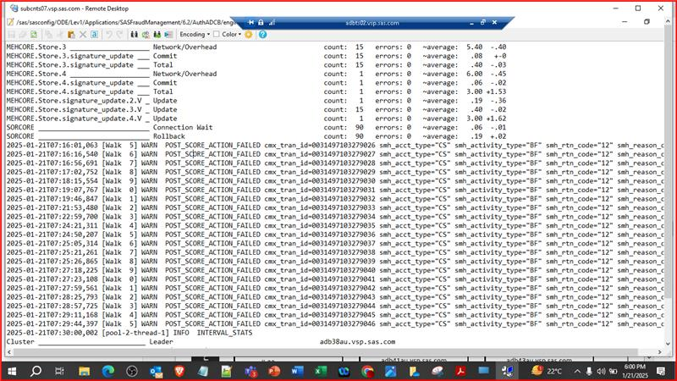

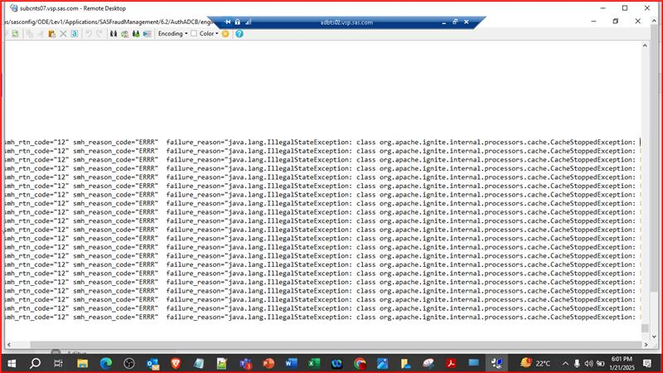

We are getting these error in the ADCB prod...we need to raise it with sas team....Giri said check with Gaurav/Shlok to raise it via sas team..I guess mail wagera krna hota h kya kisi ko?